Recursive Bayesian Estimation

A key component of what enables a robot to successfully perform navigation is sensing. In order to navigate properly, the robot needs information about its environment. This information is supplied by sensors. A major problem, however, is that the sensor data will always be corrupted by noise to some degree. That means that if the robot just uses the raw sensor data as it is, the navigation will produce erroneous results. To apprehend the fact that all measurements are in the presence of noise, filtering is needed. One approach of doing this is through Recursive Bayesian Estimation [28, p. 13], which uses probabilistic models in order to filter out the noise.

1) State-space representation

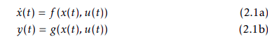
In order to define states of a system, state-space representation is used. In general, a continuous-time system is said to be in state-space form [20, p. 19] if it can be defined as

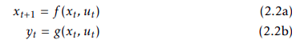
where x(t) is the system’s state vector, and u(t) and y(t) is the input and the output of the system, respectively. The derivative of the state vector x˙(t) is a function of the current state x(t) and the current input u(t). Similarly, the output of the system y(t) is a function of the current state and the current input. For discrete time systems, state-space equations [20, p. 19] are defined as

For linear continuous-time systems, the state space model can be formulated as
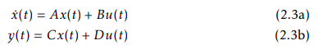

For linear discrete-time systems, the state space model can be formulated as
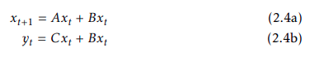

2) Bayesian Filtering

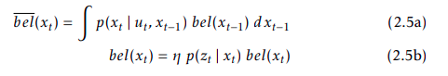
The pose of a robot is due to its current state xt . When the system enters a new state xt+1, which is due to some control command of the robot ut , the new state will produce a measurement zt+1. The relationship between controls, states, and measurements is shown in Fig. 2.1 below. A Bayes Filter is an algorithm which calculates the probability density function (PDF) for the state vector xt . This is done in two steps, the prediction step bel(xt ) and the correction step bel(xt ) as

where in the prediction step (given by Eq. 2.5a), a new state xt is predicted using only the control command ut and the previous state xt−1. This prediction is altered in the correction step by using sensor data in order to get a better estimation[28, p.27]. A scaling factor η is introduced to scale the resulting PDF in order to make the integral sum 1 [28, p.17]. Pseudo-code for the algorithm is described in Algorithm 1.

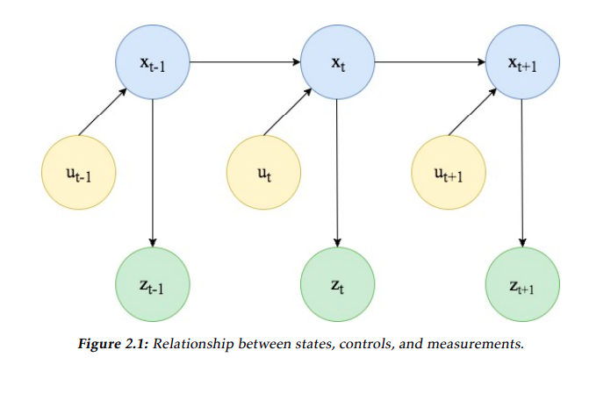
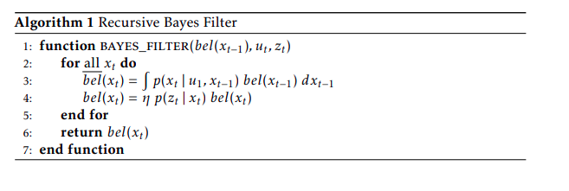

3) Kalman Filtering

A technique which implements a Bayes filter is the Kalman filter, which is used in linear Gaussian systems. Basically, it computes a belief for a continuous state [28, p.40]. This state represents the information regarding the vehicle such as the odometry, and its surrounding environment for example landmarks[28, p.20]. The belief of the state at a specific time instance t bel(xt ), can be expressed by its mean and its covariance.[28, p.40]

The Kalman filter needs three specific properties as prerequisites [28, p. 41- 42], and these are:

• The current state xt , needs to be represented by linear arguments, meaning that

where At and Bt are constants. Moreover, the added noise source should be of Gaussian nature. The current state xt depends on the previous state xt−1, the control ut , and the noise epsilon_t .

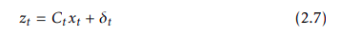
• The current measurement zt requires its arguments to be of linear nature meaning that

where Ct is a constant and the noise source is Gaussian. The current measurement zt depends on the current state xt and the noise source δt .

• The last prerequisite is that the start belief bel(x0) has to be Gaussian distributed.

The Kalman filter algorithm itself, shown below in Algorithm 2 expresses the belief of the current state xt , at a specific time t. The bel(xt ), is expressed by the mean µt and the covariance Σt , which is also the output of the algorithm.[28, p.42]

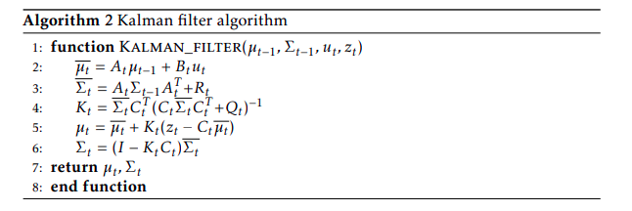
Basically, the algorithm calculates predictions of its mean µt_mean and covariance Σt_mean at line 2 and 3. Whereas At and Bt are matrices which multiplied by the state vector xt−1 and the control vector ut represents the state transition probability with linear arguments, which is one of the requirements for the Kalman filter algorithm to be successful. These predictions are used in the correction step, lines 4-6. The first step of the correction is the calculation of the Kalman gain denoted Kt . Moreover, the calculation of the mean µt is performed with regards to the predicted mean µt_mean the measurement zt - the predicted measurement (2.7) Ct µt_mean times the Kalman gain. At last, the new covariance Σt is calculated with regards to the Kalman gain factor as well as the predicted covariance Σt_mean [28, p.43].
4) EKF

The Extended Kalman Filter is an approach of dealing with nonlinear models, of which the traditional normal Kalman filter cannot handle. Basically, real world measurements and state transitions are often not linear, thus a normal Kalman filter’s assumption of linear data is not accurate. The approach of how EKF processes this is by describing the state transition probability and the measurement probability with nonlinear functions [28, p. 54]

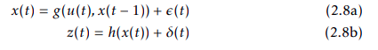

As stated above the EKF uses nonlinear functions. The output of the algorithm is an approximation in the form of a Gaussian distribution, with an estimated mean and covariance. The approximation part of the algorithm is due to the fact that it uses nonlinear functions. These functions need to go through a linearization process. This process linearizes the functions by for example using a first order Taylor expansion around a linearization point, this can be seen in Fig. 2.2. The resulting Gaussian distribution can then be calculated in closed form. This enables the extraction of interesting characteristics of the distribution such as the mean µt and the covariance Σt . Given the mean and the covariance, the belief bel(xt ) can be represented [28, p.56-58]. The EKF algorithm is shown below in Algorithm 3 [28, p.59].

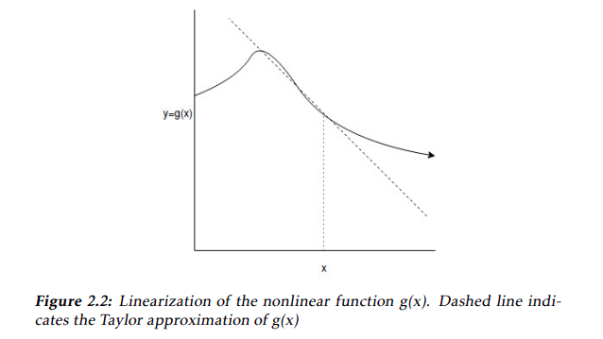

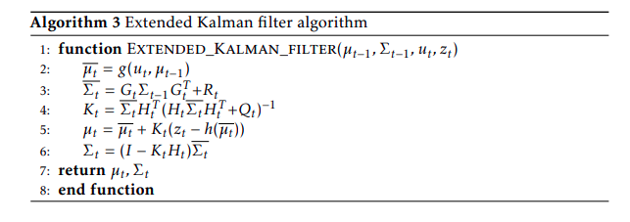

As can be seen from Algorithm 3 it is slightly different compared to the Kalman filter Algorithm 2. This is due to the fact that the EKF uses nonlinear functions to calculate the mean µt and the covariance Σt .

5) Particle Filter

Another implementation of a Bayes filter is the particle filter. In contrast to the Extended Kalman filter, it does not use a parametric model for the probability distributions. The main idea of the particle filter is that it instead keeps a set of M samples, where each sample x [m] t (known as a "particle") is a set of potential state variable values. The probability itself of these state variables is represented by how many particles contain similar state variable values, meaning that areas with high probability will have a higher density of particles than the areas where the probability is low [19, p. 27].
The particle filter is described in Algorithm 4[28, p. 98], where X˜ t is the predicted state vector, and Xt is the corrected state vector.

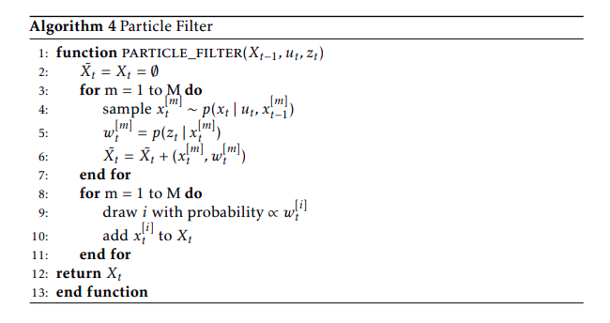
5.1 Sampling

During sampling (lines 3-7 in Algorithm 4), new values are generated for each particle in the filter. These values are only temporary, and the particles themselves will not be updated until the resampling stage. This, for each particle, new state is due to the control ut and the previous state of the particle xt^[m] . After this, the importance factor wt^[m] is calculated. The importance factor is due to the measurement zt and is used as a likelihood measure of the particle used in the forthcoming resampling of the particle filter. [28, p. 99]

5.2 Resampling

During resampling (lines 8-10 in Algorithm 4) the actual particles in the filter are updated. This is done by randomly selecting a particle generated in the sampling stage, where the probability of selection for each particle is due to its importance factor. The resampling is done with replacement, so each particle can be drawn several times. [28, p.99]

5.3 Rao-Blackwellized Particle Filer

There’s also another version of the Particle Filter called the Rao-Blackwellized particle filter. This is an extension of the regular particle filter where some state variables are represented by particles, and some with Gaussians. [28, p. 437]

